Homework Assignment 2 (Due Day: May 18, 2017)

Name: **Princess Kim** PSU_ID: **967760113** Email: [prikim@pdx.edu](mailto:prikim@pdx.edu)

Submission Date**: 5/18/2017**  Late Days Used: **0**

Collaboration Acknowledgement: **Eunji (Zoey) Lee, Chris M.**

## Solutions of 7.17

Class JobQueueClass

{

Public:

JobRecord Class *frontOfQueue;

JobRecordClass *rearOfQueue;

Void initializeJobQueue()

{

frontOfQueue = NULL;

rearOfQueue = NULL;

}

Void addJobToQueue(int JobNumber)

{

JobRecordClass * aJob = new JobRecordClass();

aJob.JobNo = JobNumber;

aJob -> inFront = rearOfQueue;

aJob -> inRear = NULL;

rearOfQueue -> inRear = aJob;

rearOfQueue = aJob;

}

Int removeJobFromQueue()

{

Int JobNumber = frontOfQueue.JobNo;

frontOfQueue = frontOfQueue -> inRear;

frontOfQueue -> inFront = NULL;

return JobNumber;

}

};

## Solutions of 12.8

In order for the product to determine whether a bank statement is correct, the following is needed:

1. Balance at the beginning of the month
2. The number, date, and amount of each check
3. The date and amount of each deposit
4. And the balance at the end of the month.

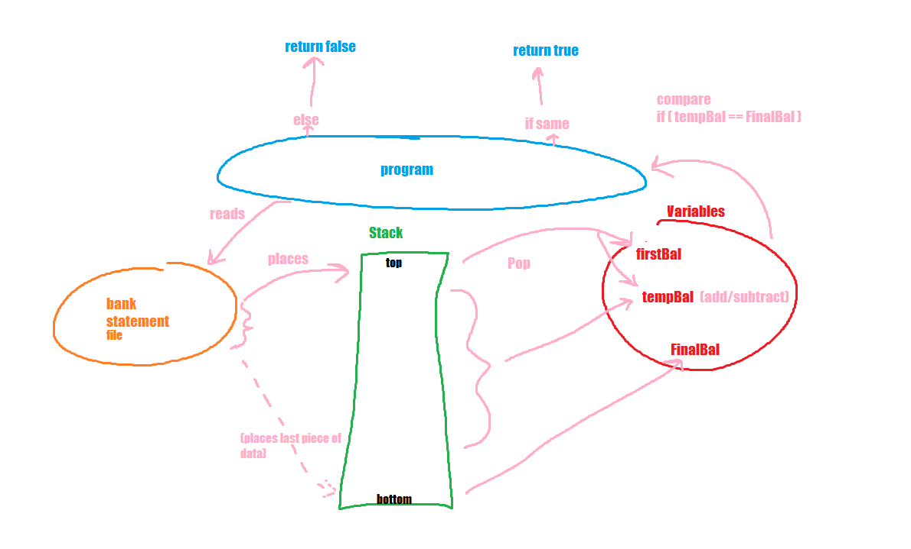As for the program, the first step is to open the bank statement file, with the above requirements held in corresponding variables. Bank statements are read from line to line, with the top of the line starting with the balance at the beginning of the month, and the end being the balance at the end of the month. The variable name is firstBal, FinalBal, TempNum, Date, TempDate, TempAmount, and TempBal. Each line is read and placed onto a stack, which continues until the whole file is read. The stack is then popped from the top, whilst extracting the data. The first pop is stored in firstBal and tempBal, and the rest of the pops have the amount deducted or deposited added (or subtracted) to tempBal. When the stack is empty, the tempBal is compared to the FinalBal (the balance at the end of the month). If both variables are the same, then the bank statement is correct and returns true (else returns false).

## Solutions of 12.9

## Solutions of 12.13

|  |  |  |  |  |
| --- | --- | --- | --- | --- |
| **Current State Movement** | **Table of Next States Input** | **Sign** | **Bit String** | **Binary Point** |
| *0* | *Sign* | *Invalid* | *Invalid* | *Invalid* |
| *1* | *Sign* | *Invalid* | *Invalid* | *Invalid* |
| *+* | *Bit String* | *Bit String* | *Bit String* | *Valid* |
| *-* | *Bit String* | *Bit String* | *Bit String* | *Valid* |
| *.* | *Binary Point* | *Invalid* | *Binary Point* | *Invalid* |

## C:\Users\Princess\Desktop\analysis workflow diagram.pngSolutions of 13.20

## C:\Users\Princess\Desktop\14.14.pngSolutions of 14.14